Assemblies
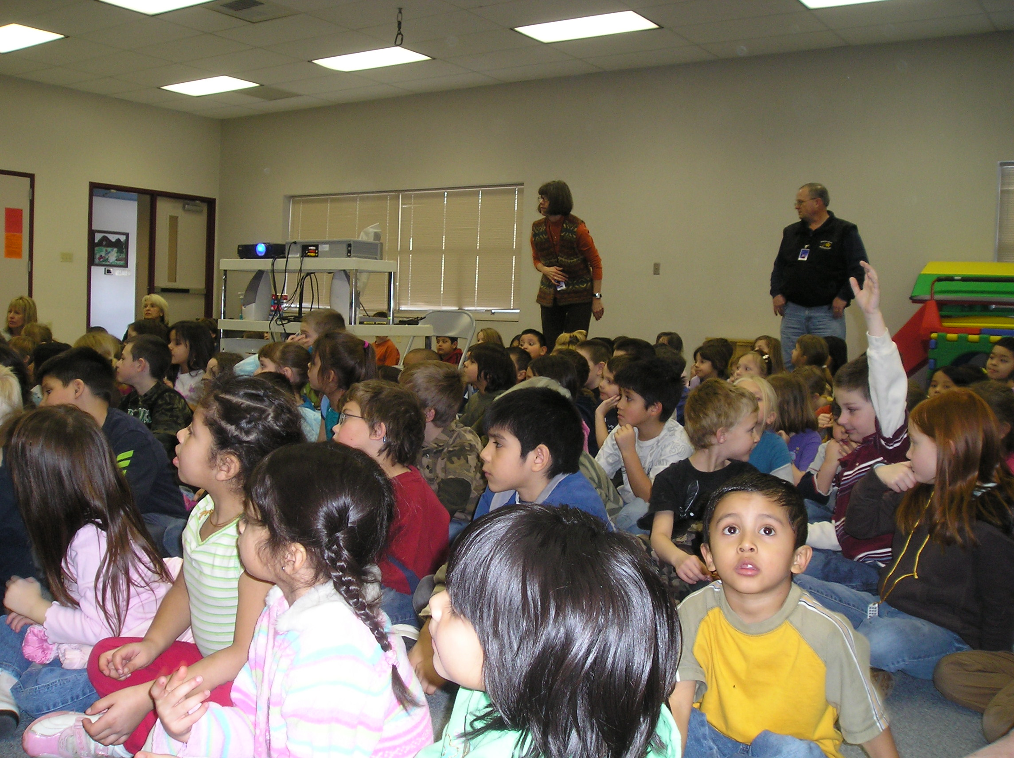
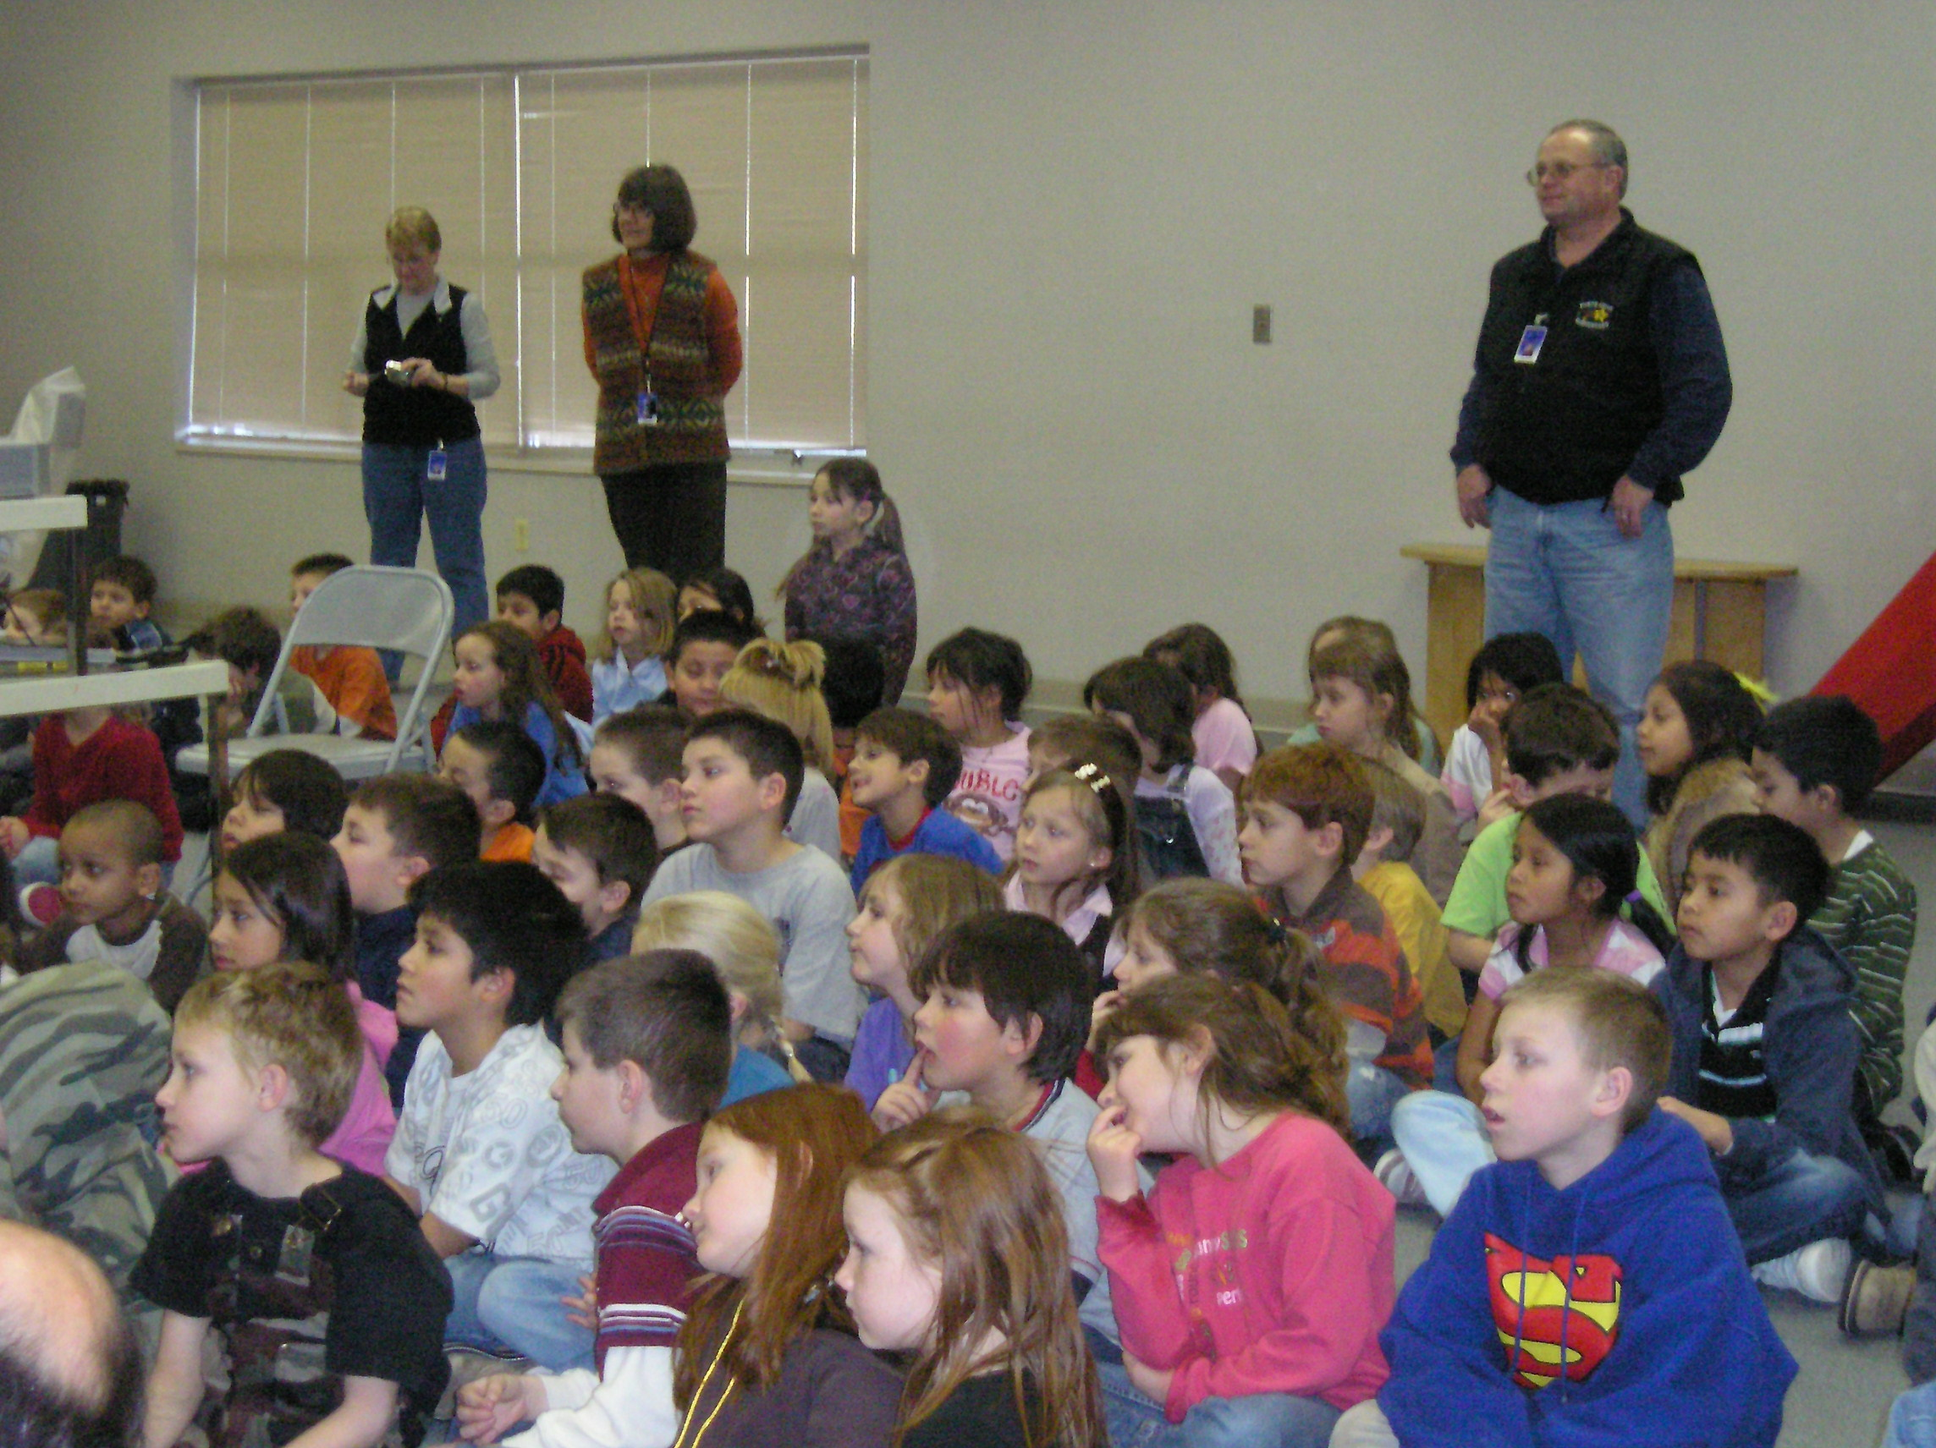

- Sit criss-cross applesauce.
- Keep hands and feet to yourself.
- Be a good audience:
By focusing eyes and ears on the presenter.
By listening.
By raising your hand for questions, only when asked.
By clapping appropriately when presenter is finished.
By waiting for your teacher’s signal before standing.

